**HANDOVER SCENARIOS**

If reception conditions deteriorate during a call because of a change in the location of the subscriber, the BSC has to initiate a handover procedure. The basic procedure and the necessary messages have already been shown in Figure 1.29. Depending on the parts of the network that are involved in the handover, one of the following handover scenarios described in 3GPP TS 23.009 [32] is used to ensure that the connection remains established:

● **Intra‐BSC handover**. In this scenario, the current cell and the new cell are connected to the same BSC. This scenario is shown in Figure 1.30.

The network receives these measurement values and is thus able to periodically evaluate if a handover of an ongoing call to a different cell is necessary. Once the BSC decides to perform a handover, a TCH is activated in the new cell as shown in Figure 1.29. Afterward, the BSC informs the mobile device via the old cell with a handover command message that is sent over the FACCH. Important information elements of the message are the new frequency and timeslot number of the new TCH. The mobile device then changes its transmit and receive frequency, synchronizes to the new cell if necessary and sends a handover access message in four consecutive bursts. In the fifth burst, a Set Asynchronous Balanced Mode (SABM) message is sent, which is acknowledged by the BTS to signal to the mobile device that the signal can be received. At the same time, the BTS informs the BSC of the successful reception of the mobile device’s signal with an establish indication message. The BSC then immediately redirects the speech path to the new cell.

From the mobile’s point of view the handover is now finished. The BSC, however, has to release the TCH in the old cell and has to inform the MSC of the performed handover before the handover is finished from the network’s point of view. The message to the MSC is only informative and has no impact on the continuation of the call

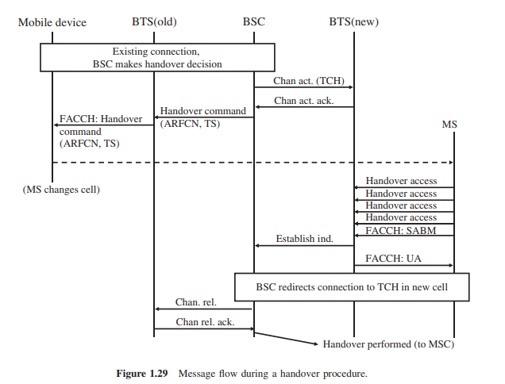

● **Inter‐BSC handover**. If a handover has to be performed to a cell which is connected to a second BSC, the current BSC is not able to control the handover itself as no direct signaling connection exists between the BSCs of a network. Thus, the current BSC requests the MSC to initiate a handover to the other cell by sending a handover request message. Important parameters of the message are the cell ID and the LAC of the new cell. As the MSC administers a list of all LACs and cells under its control, it can find the correct BSC and request the establishment of a TCH for the handover in a subsequent step. Once the new BSC has prepared the speech channel (TCH) in the new cell, the MSC returns a handover command to the mobile device via the still existing connection over the current BSC. The mobile device then performs the handover to the new cell. Once the new cell and BSC have detected the successful handover, the MSC can switch over the speech path and inform the old BSC that the TCH for this connection can be released.

● **Inter‐MSC handover**. If the current and new cells for a handover procedure are not connected to the same MSC, the handover procedure is even more complicated. As in the previous example, the BSC detects that the new cell is not in its area of responsibility and thus forwards the handover request to the MSC. The MSC also detects that the LAC of the new cell is not part of its coverage area. Therefore, the MSC looks into another table that lists all LACs of the neighboring MSCs. As the MSC in the next step contacts a second MSC, the following terminology is introduced to unambiguously identify the two MSCs: the MSC which has assigned an MSRN at the beginning of the call is called the Anchor‐Mobile Switching Center (A‐MSC) of the connection. The MSC that receives the call during a handover is called the Relay‐Mobile Switching Center (R‐MSC) (see Figure 1.44)

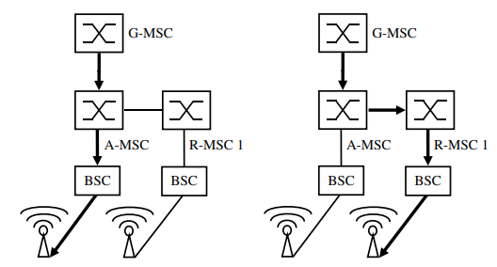

**Figure 1.44 Inter‐MSC handover**

To perform the handover, the A‐MSC sends an MAP (see Section 1.4.2) handover message to the R‐MSC. The R‐MSC then asks the responsible BSC to establish a TCH in the requested cell and reports back to the A‐MSC. The A‐MSC then instructs the mobile device via the still existing connection over the current cell to perform the handover. Once the handover has been performed successfully, the R‐MSC reports the successful handover to the A‐MSC. The A‐MSC can then switch the voice path toward the R‐MSC. Afterward, the resources in the old BSC and cell are released.

If the subscriber changes again during the call to another cell controlled by yet another MSC, a subsequent inter‐MSC handover has to be performed as shown in Figure 1.45.

For this scenario, the current Relay‐MSC (R‐MSC 1) reports to the A‐MSC that a subsequent inter‐MSC handover to R‐MSC 2 is required to maintain the call. The A‐MSC then instructs R‐MSC 2 to establish a channel in the requested cell. Once the speech channel is ready in the new cell, the A‐MSC sends the Handover Command message via R‐MSC 1. The mobile device then performs the handover to R‐MSC 2 and reports the successful execution to the A‐MSC. The A‐MSC can then redirect the speech path to R‐MSC 2 and instruct R‐MSC 1 to release the resources. By having the A‐MSC in command in all the different scenarios, it is ensured that during the lifetime of a call

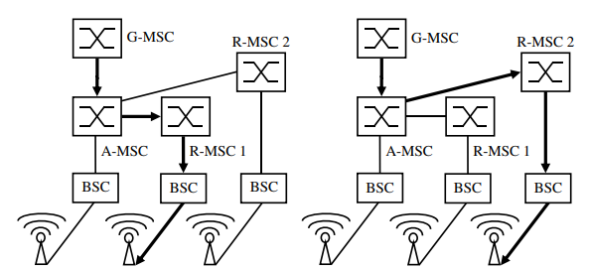

**Figure 1.45 Subsequent inter‐MSC handover**

only the G‐MSC, the A‐MSC and at most one R‐MSC are part of a call. In addition, tandem switches might be necessary to route the call through the network or to a roaming network. However, these switches purely forward the call and are thus transparent in this procedure.

Finally, there is also a handover case in which the subscriber who is served by an R‐MSC returns to a cell which is connected to the A‐MSC. Once this handover is performed, no R‐MSC is part of the call. Therefore, this scenario is called a subsequent handback.

From the mobile device point of view, all handover variants are performed in the same way, as the handover messages are identical for all scenarios. To perform a handover as quickly as possible, however, GSM can send synchronization information for the new cell in the handover message. This allows the mobile device to immediately switch to the allocated timeslot instead of having to synchronize first. This can only be done, however, if the current and the new cells are synchronized with each other, which is not possible, for example, if they are controlled by different BSCs. As two cells that are controlled by the same BSC may not necessarily be synchronized, synchronization information is by no means an indication of what kind of handover is being performed in the radio and core network